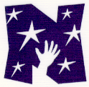
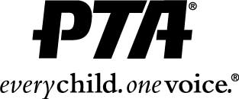
Northwood Elementary PTA
Funds Received Form
Date_______________ Activity_________________________________________________
Line Item to be Credited (your committee)__________________________________________

Money Collected
Currency |  | Number of Each Bill | Subtotals
Ones | 1 x |  | = $
Fives | 5 x |  | = $
Tens | 10 x |  | = $
Twenties | 20 x |  | = $
Fifties | 50 x |  | = $
Hundreds | 100 x |  | = $
Checks |  |  | $
Coins |  |  | $
Total Funds Received $

The undersigned certify that the funds shown above were received for PTA activities, were properly accounted for, and will be credited to the appropriate PTA account as noted.
Signatures:
1)_________________________________________________________________
2)_________________________________________________________________
All funds, along with this form, should be turned over to the Treasurer immediately upon completion of the activity that generated the funds. Two people should participate in the procedure of counting funds and signing this form. If appropriate, a receipt will be issued to verify the amount of money turned over to the Treasurer.

For Treasurer’s Use Only
Amount Received:___________________________ Date Rec’d:__________________
Line Item Credited:______________________________________________________
Receipt Issued:________Yes _____________No Reivsed 4/2012

